RESOLUTION NO.__________

RE: CERTIFICATE OF APPROPRIATENESS UNDER THE
PROVISIONS OF THE ACT OF THE PENNSYLVANIA
LEGISLATURE 1961, JUNE 13, P.L. 282 (53
SECTION 8004) AND BETHLEHEM ORDINANCE NO.
3952 AS AMENDED.

WHEREAS, it is proposed to replace an existing electrical fixture with a gas lantern at 42 W. Market St.

NOW, THEREFORE, BE IT RESOLVED by the Council of the City of Bethlehem that a Certificate of Appropriateness is hereby granted for the proposal.

Sponsored by: (s)

(s)

ADOPTED BY COUNCIL THIS DAY OF

(s)
President of Council

ATTEST:

(s)
City Clerk

HISTORICAL & ARCHITECTURAL REVIEW BOARD

The applicant is proposing to replace an existing electrical fixture with a gas lantern at 42 W. Market St.
APPLICATION #1:

Timothy Shannon & Paige Van Wirt
42 W. Market Street
Bethlehem, PA 18018

OWNER:

__________________________________________________________________________

The Board upon motion by Marsha Fritz and seconded by Nancy Shelly adopted the proposal that City Council issue a Certificate of Appropriateness for the following:

- Install a new copper and glass gas lantern.

- To be wall mounted and the size increased from 16” to 18”.

3. The motion was unanimously approved.
__________________________________________________________________________

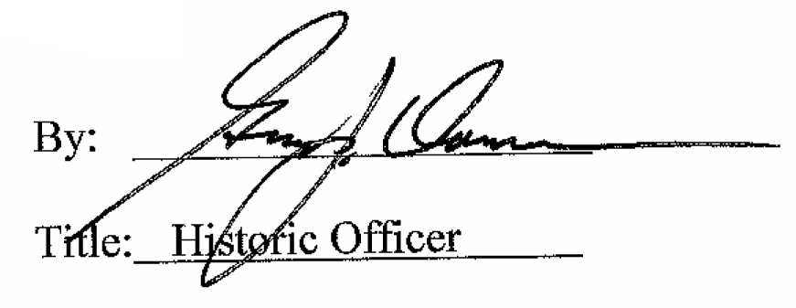

Date of Meeting: December 7, 2016

